EX:10B

DATE: 1/10/2024

# 

# PING TO TEST SERVER CONNECTIVITY USING SOCKETS

**AIM:** To develop ping program to test server connectivity using sockets.

# ALGORITHM:

## Server.py

1. Import the socket package
2. Initialize local IP address and local port.
3. Create a socket using socket() function
4. Bind the IP address and port number.
5. Accept client request for connection.
6. Print the received connection details
7. Send reply message to the client.
8. Close the connection.

## Client.py

1. Import the socket package
2. Initialize server IP address and local port.
3. Create a socket using socket() function.
4. Start the timer.
5. Send message to the server.
6. The reply message of the server is received.
7. The timer is stopped.
8. Print the round trip time statistics.

**Ping to test server connectivity using sockets**

## Client code:

from socket import * from os import system

s = socket(AF_INET, SOCK_STREAM) s.connect(("127.0.0.1",8000)) # Connect op='connect'

s.send(op.encode('utf-8')) # Send request

data = s.recv(100).decode()# Get response print(data)

system("ping "+ gethostname()) s.close()

### Server Code:

from socket import * from os import system

s = socket(AF_INET,SOCK_STREAM) s.bind(("",8000))

s.listen(5) while True:

c,a = s.accept()

print("Received connection from", a) data=c.recv(100).decode() print(data)

c.send(data.encode('utf-8')) system("ping "+ a)

c.close()

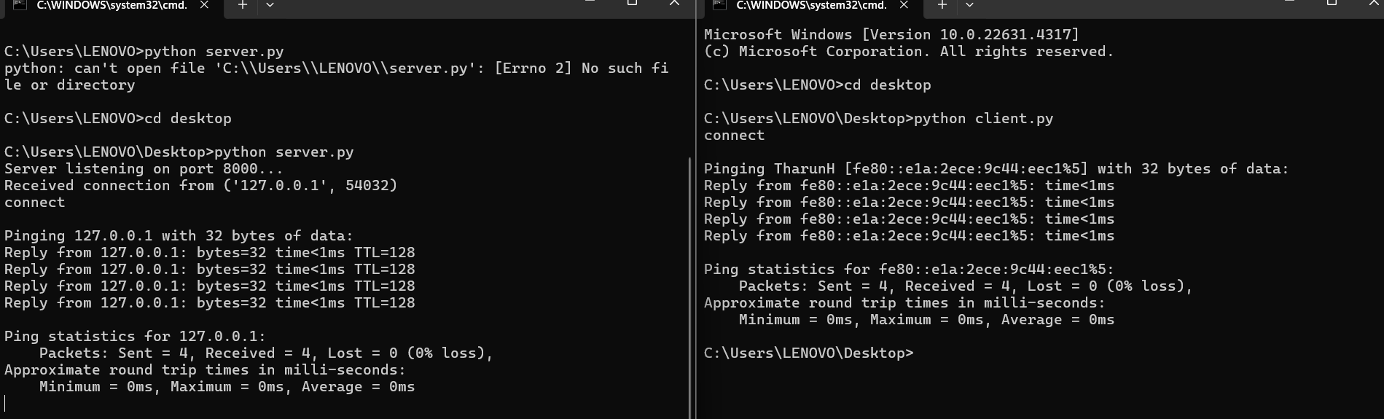

**RESULT:** server connectivity using sockets has been tested using ping command